animated_text_kit plugin

Exercise #1

Flutter Developer Bootcamp

# **Purpose**

This exercise demonstrates how to use the animated_text_kit package to create various text animations in a Flutter application.

**Problem**

In the provided Exercise You need to create as follows:

In the given exercise implement an animated_text_kit package to create various text animations within a StatelessWidget called Teight. The widget features an app bar and a scrollable body with different text animations, each in a separate container with unique background colors and heights.The colorizeAnimation method animates text colors, rotateAnimation rotates through text strings, scaleAnimation scales text sizes, fadeAnimation fades text in and out, and typeAnimation simulates typing text. Each animation repeats indefinitely, showcasing how to enhance Flutter applications with animated text effects.

**How to Solve**

1. Checkout the exercise from Git Repo:

git clone -b <user-branch> <repo-URL>

2. Open the root folder inside VS Code

3. To build the app click the run option in the main method{}

4. Imports:

* animated_text_kit
* flutter/material.dart
* flutter/services.dart

5. Colorize Animation:

* Teal container, height 150
* AnimatedTextKit with ColorizeAnimatedText
* Texts: "Cat", "Dog", "Fish"
* Colors: purple, blue, yellow, red
* Font size: 30, repeats indefinitely

6. Rotate Animation:

* Orange container, height 150
* AnimatedTextKit with RotateAnimatedText
* Texts: "Rabit", "Snake", "Hamster"
* Font size: 30, white, repeats indefinitely

7. Scale Animation:

* Blue container, height 150
* AnimatedTextKit with ScaleAnimatedText
* Texts: "Camel", "Cow", "Goat"
* Font size: 40, repeats indefinitely

8. Fade Animation:

* Brown container, height 150
* AnimatedTextKit with FadeAnimatedText
* Texts: "White molly", "Black molly", "Guppy"
* Font size: 32, bold, repeats indefinitely

9. Type Animation:

* Blue-grey container, height 150, padding 20
* AnimatedTextKit with TyperAnimatedText
* Texts: "Persian cat", "Calico", "Siberian Cat", "American curl"
* Font size: 20, repeats indefinitely

9. Go To File: <specific-file-with--method> à <method-name>, implement your logic.

**You will Achieve**

When you complete this Exercise you will learn the following:

**Imports Included :**

* **package:animated_text_kit/animated_text_kit.dart**
* For text animation widgets.
* **package:flutter/material.dart**
* For building the UI components.
* **package:flutter/services.dart**
* For controlling system UI settings.

**Widgets Included :**

* **Scaffold:**
* Provides the basic material design visual layout structure.
* **AppBar:**
* Contains a title, background color, and centered text.
* **SingleChildScrollView:**
* Makes the body scrollable.
* **Column:**
* Arranges the animation widgets vertically.
* **Container:**
* Used to style and contain each animated text widget.
* **Center:**
* Centers the animated text within the container.
* **AnimatedTextKit:**
* Parent widget for animated text, with properties to repeat animations.

**Animated Text Widgets Used :**

* **ColorizeAnimatedText:**
* Animates text colors.
* **RotateAnimatedText:**
* Rotates through different text strings.
* **ScaleAnimatedText:**
* Scales text sizes up and down.
* **FadeAnimatedText:**
* Fades text in and out.
* **TyperAnimatedText:**
* Simulates typing text.

# **Screenshots**

## **Expected output(animated_text_kit plugin)**

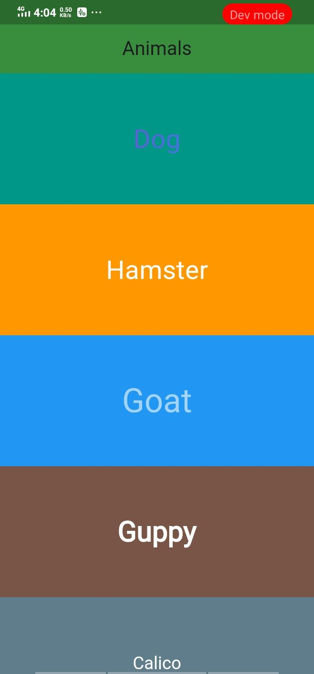

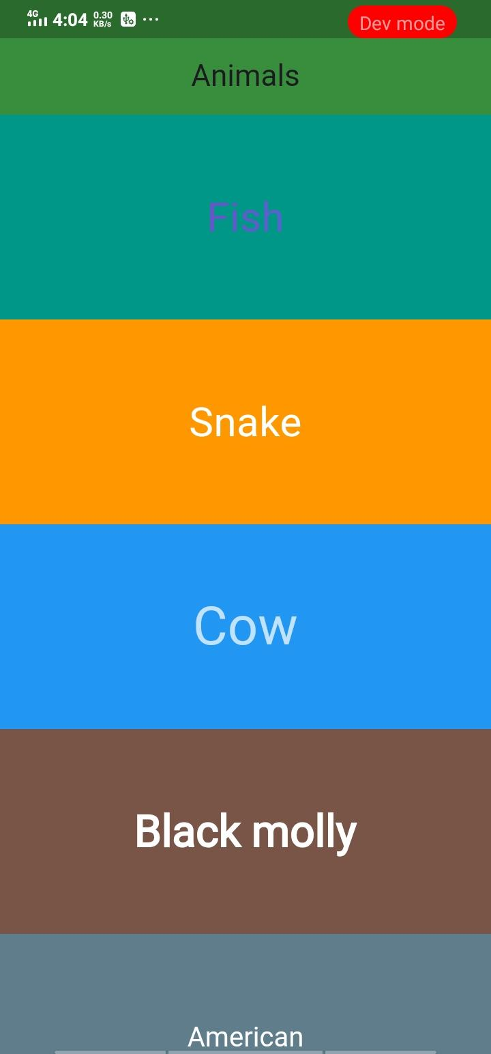

# **How to submit your Exercise**

Push your project back to the same git branch using command:

<command name>

# **Happy Coding!**